DIFC Data Protection Law Compliance for Log360
Tagline: Support DIFC data protection compliance with log monitoring and reporting from Log360.

Overview
The DIFC Data Protection Law (Amended 2025) Compliance extension for Log360 helps DIFC-registered businesses and data controllers meet the updated personal data security, breach notification, and accountability requirements under the amended DIFC Data Protection Law.
Log360 monitors access to personal data across cloud platforms, databases, and application environments, maintaining detailed audit trails that demonstrate due diligence to the DIFC Commissioner of Data Protection. Security and compliance teams can detect unauthorized data processing, investigate incidents rapidly, and generate reports aligned to DIFC regulatory expectations.

Key Features
- Generate predefined compliance reports covering personal data access, user authentication, and system security events aligned to the DIFC Data Protection Law.
- Detect unauthorized access to personal data across cloud and on-premises environments using real-time correlation and anomaly detection.
- Configure alerts for data breach indicators such as bulk data exports, unusual access patterns, and unauthorized third-party data transfers.
- Export audit-ready reports in PDF and CSV formats for DIFC Commissioner submissions and internal data protection officer records.



Screenshots
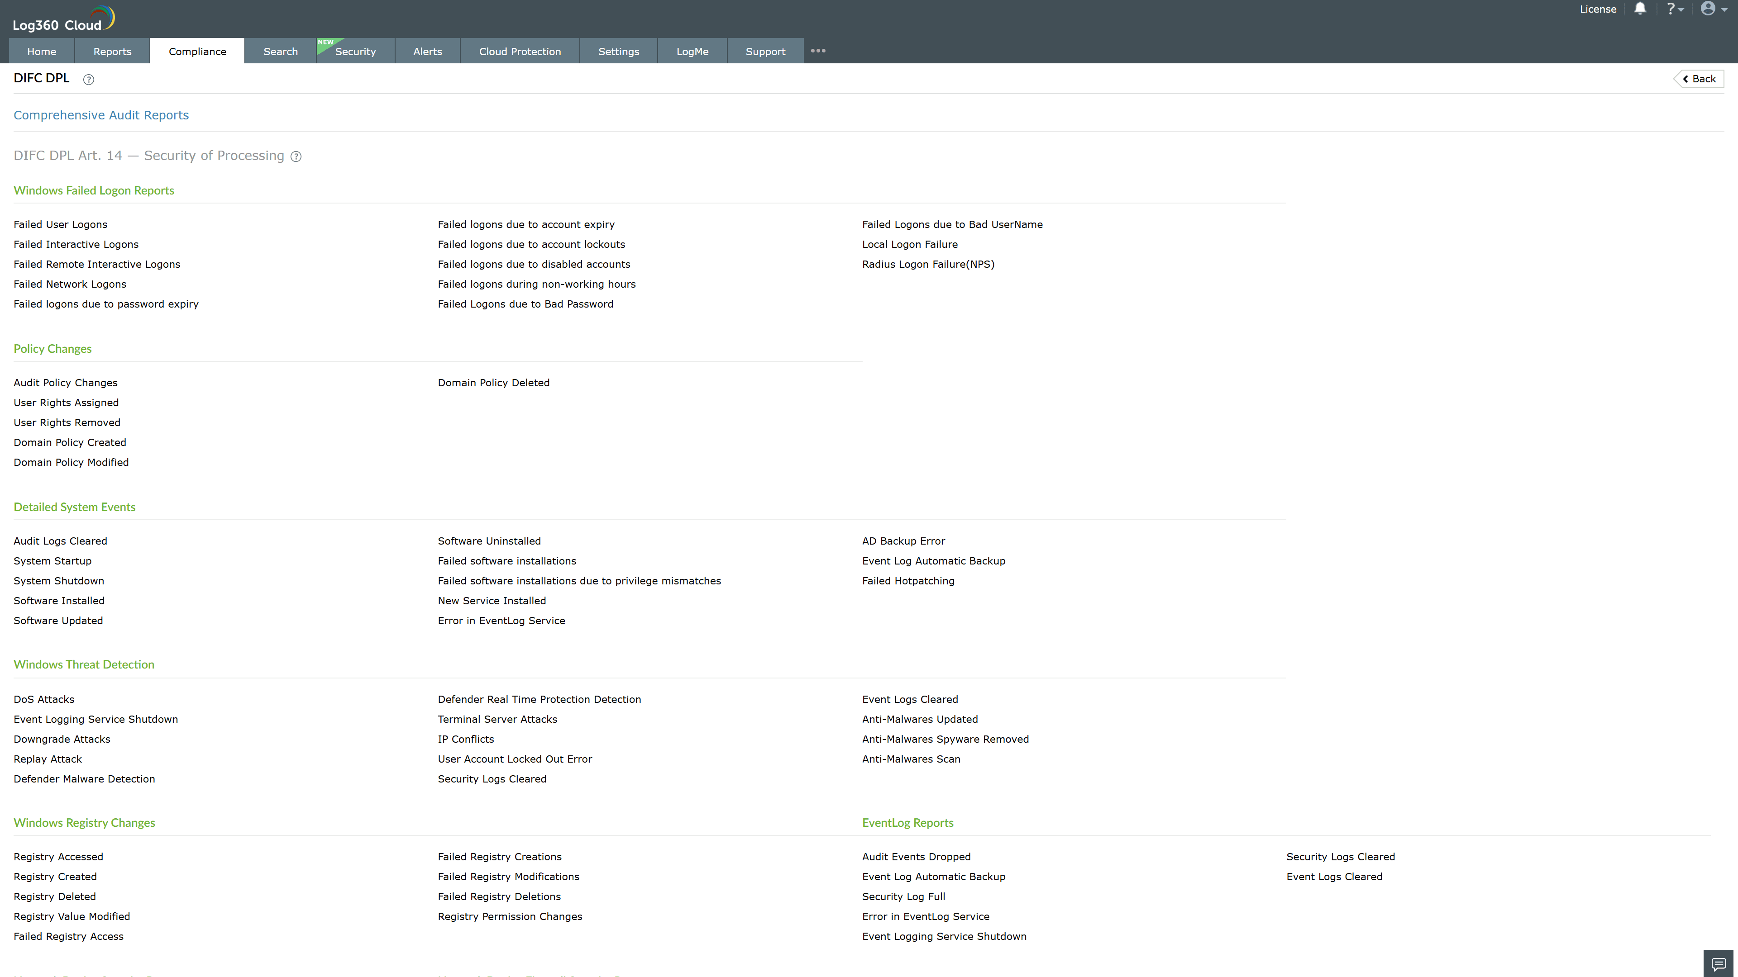
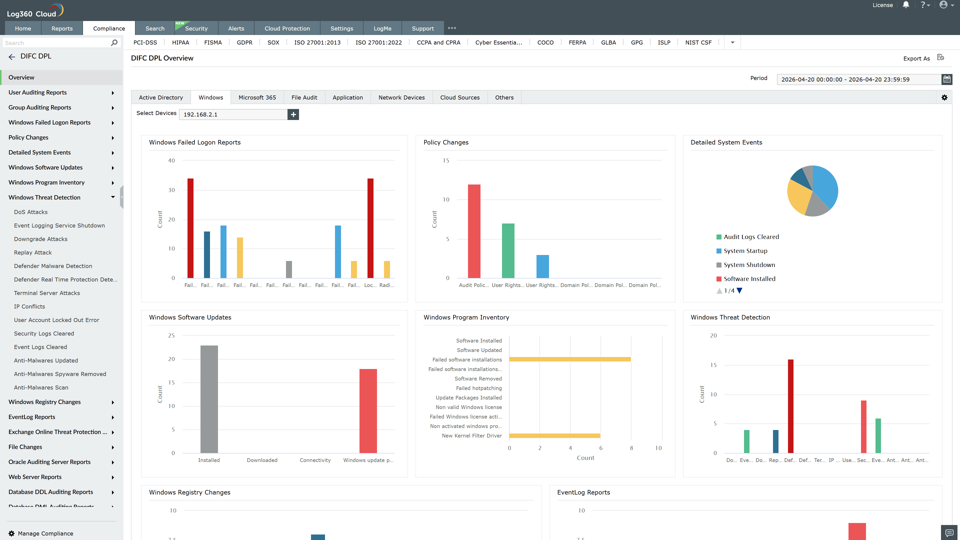
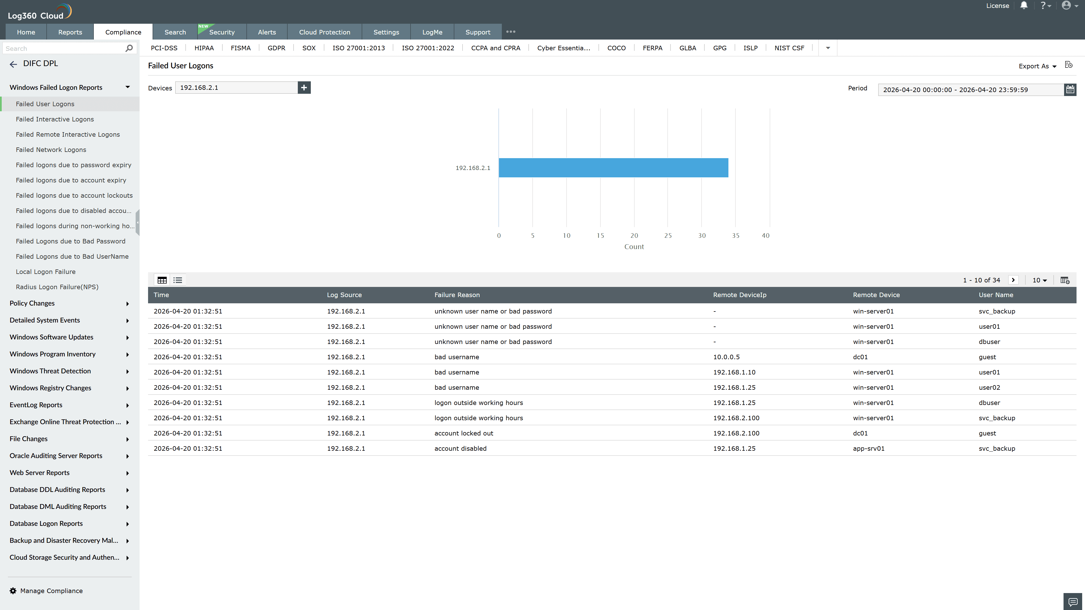
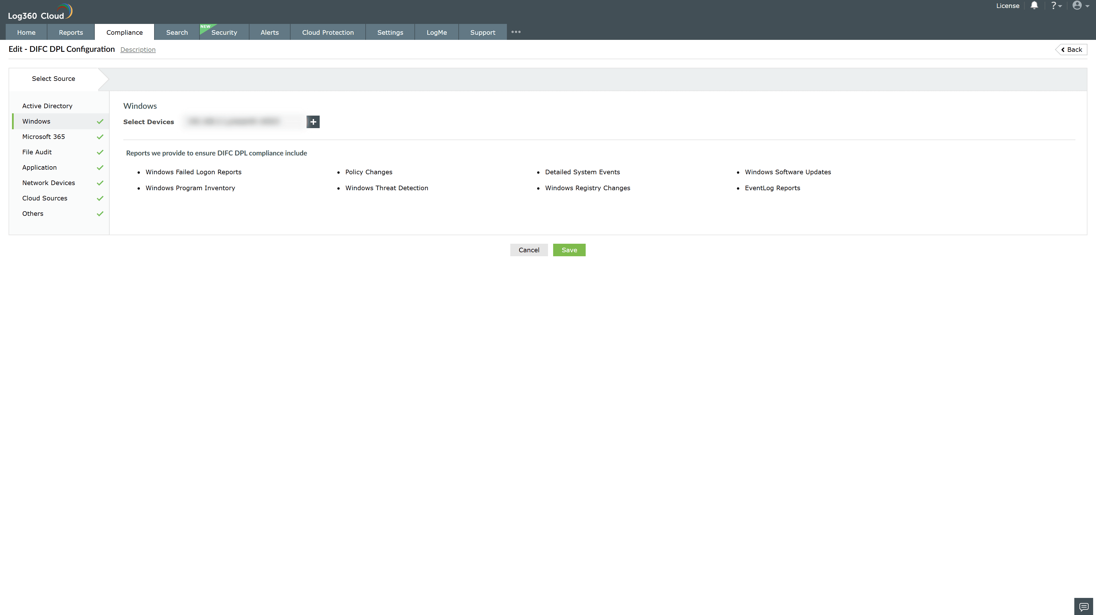

Valid Submission : Yes
Supported Editions : Free, Basic, Standard, Professional, MSSP
Help Document : https://www.manageengine.com/log-management/help/integrations/compliance-extensions.html
Help Video : Not provided
Tags : Log360, Compliance, Privacy monitoring, Data privacy, Regulatory compliance
Supported DCs : US, IN, JP, CA, AU, UK and EU
Privacy Policy:
Terms of Service:
Release Notes:
Predefined reports for the DIFC Data Protection Law (Amended 2025) Compliance

